Jefferson Terrace Academy
Virtual Learning Syllabus
5601 Upton Drive
Baton Rouge, LA 70809
225-293-3210 (office) 225-291-6627 (fax)
Website: www.jtatigers.org Facebook: @jeffersonterraceelementary
Hello Parents!

The EBRP school district has announced that we will be virtual until after Labor Day this year. The first day of the 2020-2021 school year will be Monday, August 10, 2020. We have been working with our teachers to create flexible schedules that will enable all students to participate in live lessons each day with their teachers. Several of these lessons will be recorded, and other instructional activities will be posted to meet the needs of the students who are not able to participate in the live lessons. These live lessons will be broken into segments of whole group sessions, small group instruction, and intervention and enrichment opportunities.

Attendance in virtual learning is MANDATORY!!! Students are expected to complete the attendance requirement everyday by completing and submitting the Google Form. Students must sign-in by 8:30 a.m. You can access the form by typing the following url into the browser of your phone or computer.
https://forms.gle/jrCSikGyGDwAfydY9

In order for students to login in to the school provided device, all students must hold their badge up to the webcam located at the top of the Chromebook . Below you is the login information for your student. All students should use this information to login to the computer that was provided by the school, access Google Classroom, Clever as well as other education sites that we will use throughout the school year.

Should your child have any questions about the work, his/her first point of contact should be the teacher. More information on how to contact school staff is included in this syllabus. Please remember that Google Classroom allows for two-way communication so you will have the option to openly communicate with your child's teachers at any time. Additionally, many teachers utilize REMIND as a tool, and there is always e-mail.

Your students’ needs are our number one priority and our teachers and staff are working hard to develop schedules that will enable all students to be successful!!!

Please feel free to reach out if you have any questions.
Mr. Zane Whittington, Principal
Jefferson Terrace Academy

Teacher Contact Information
Class Website
https://sites.google.com/ebrschools.org/jtasecondgrade/home
Remind App www.remind.com/join/jt219

Teacher - Mr. Berthelot (Mr. B):
email: TBerthelot @ebrschools.org

Teacher - Mrs. Bihm:
email: TBihm@ebrschools.org

Teacher - Ms. Moppert:
email: Omoppert@ebrschools.org

School Administrators Contact Information
Mr. Zane Whittington, Principal
ZWhittington@ebrschools.org
Ms. Sharon C. Thomas, Assistant Principal Mrs. Ashley Patterson, Dean of Students
SThomas5@ebrschools.org AKelly3@ebrschools.org
Mrs. Sonya Williams Fields, School Counselor
Sfields2@ebrschools.org
Student Contact Information  Jefferson Terrace must have accurate email addresses, mailing addresses, telephone numbers, and emergency numbers for emergency and administrative reasons. If you move or change the telephone number where you can be reached during the day, notify the school immediately so we can keep our files current and be able to reach you in the event of an illness or emergency situation.  You may email any updated contact information to:  Ms. Kimberly Isom, School Clerk  KIsom@ebrschools.org  or  Ms. Zea Wallace, Executive Secretary ZWallace@ebrschools.org |  |  |  | Please contact us by email if you would like to make an appointment to speak with us virtually.
Parent Home Access Center

Jefferson Terrace is pleased to offer access to the East Baton Rouge Parish School System’s Home Access Center. Accessing this software will provide you with another means of monitoring your child’s academic and disciplinary progress as well as school attendance. Access to the site does require registration and you will need a passcode to register. Please visit or call the school’s front office for more assistance. The website can be accessed at ebr.edgear.net/progress
Kindergarten Grading Scale  O = 92.5 – 100  S = 79.5 – 92.4  N = 66.5 – 79.4  U = 0 – 66.4  1st – 6th Grading Scale  A = 93 - 100  B = 85 - 92  C = 75 – 84  D = 67 – 74  F = 66 -0 |  |  | Assignments and Classwork  It is important that students learn to honor and meet due dates and deadlines for class assignments. Students must adhere to due dates and deadlines assigned by the teacher. If a student misses a published due date, his or her grade for that assignment can be reduced at the teacher’s discretion. A student who misses a due date that was previously assigned because of an approved excused absence must submit the assignment the next time she reports to class. Teachers will not refuse to accept students’ work that is late because of an excused absence.
Student Work Packets  Samples of each student’s work will be sent home every two weeks (see the school calendar).  Student’s work samples will represent a cross section of the student’s class work.  www.jtatigers.org |  |  | Google Classroom Codes  Mr. Berthelot: yhjcnxg  jcnxg  Mrs. Bihm: 4haq26r  Ms. Moppert: p73ox4g  Note: Be sure to first log into student’s school google account to access Google Classroom
Frequently Asked Questions (FAQs

What should my child wear during virtual instruction? Students should wear his or her school uniform or school spirit shirt.

Does my child have to be logged on at a certain time each day?
Yes! Each day, teachers will present lessons at designated times on a consistent schedule. Students are strongly encouraged to log in to view the live presentation, or if students are not able to attend the live lesson, to go back and watch the recording or other instructional videos at a later time. Teachers will also schedule live small group lessons and intervention/enrichment groups that will allow for deeper engagement and student collaboration. Small group sessions will not be recorded.

What will my child’s schedule look like?
We have tried to make the virtual schedule as similar to a regular day as possible, and also included as much recorded information to meet all of the needs of our families. Each grade’s schedule will look a little different; but they will all have several commonalities.

How will my child turn in his/her work?
Most assignments will be turned in through Google Classroom. Upon our return to “in-person” school, ALL students will be granted a one-week amnesty period to submit assignments to teachers without penalty. However, my advice—DO NOT allow the work to pile up. Stay on top of it. We don’t know for sure how long we will be out of school.

What if my child doesn’t have access to instructional technology or the internet?
Our teachers are meeting with each of their classes today. Instructional packets are being issued to those students who have limited or no access at home. Contact the appropriate teacher if you have questions about the work, or perhaps, need additional work. We will problem solve ways to provide any student with additional work who do not have internet/computer access.

I believe in you all! You can do this! We will get through this! Continue to pursue excellence EVERY DAY in EVERY WAY, even at home.

Virtual Student Schedule
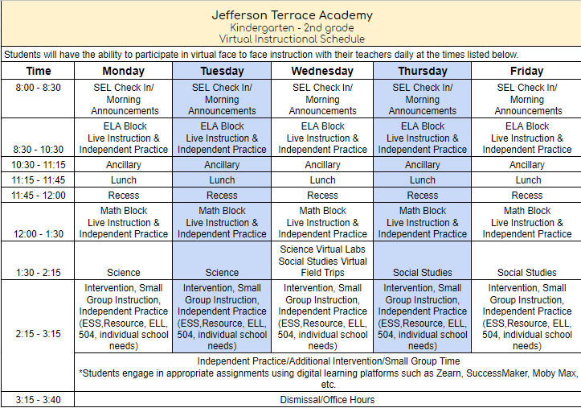

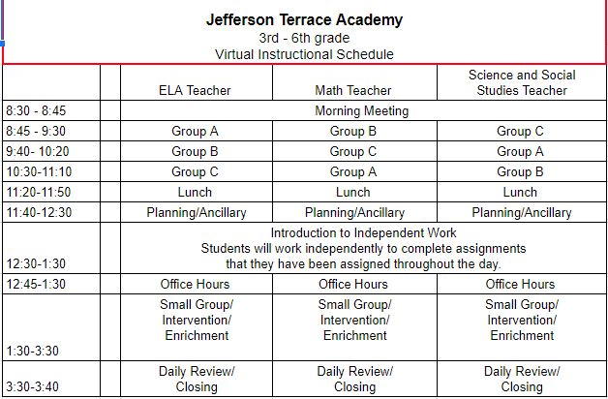

Curriculum Scope and Sequence

1st Nine Weeks  Dates:  August 10 - October 14 | Math-Addition and Subtraction up to 100, Place Value  ELA-Reading and writing about schools and community  Science-Land and water in Louisiana  Social Studies Community and geography
2nd Nine Weeks  Dates:  October 15 - December 18 | Math- Addition and Subtraction up to 200, Word Problems  ELA- Reading and writing about science and story  Science-Bodies of water and migratory birds  Social Studies- Community and heritage
3rd Nine Weeks  Dates:  January 6 - March 9 | Math-Addition and Subtraction up to 100, Foundations of Multiplication and Division  ELA-Reading and writing research  Science- Animal habitats  Social Studies- Government and leaders
4th Nine Weeks  Dates:  March 9 - May 20  SCHOOL CALENDAR | Math-Length, Money, Time, and Shapes, Introduction to Fractions  ELA-Reading and writing pollination  Science- Changes and properties of matter  Social Studies- Economy and culture
First Nine Weeks Family Engagement Community Event

Event: Virtual Fun Night!
Date: 9-11-2020
Time: 7:00 pm

Enter other classroom/grade level information

“You’re off to Great Places! Today is your day!
Your mountain is waiting, So… get on your way!”
Dr. Seuss
Welcome students and parents. We have a brand new school this year to help us have a fun, challenging, and exciting time in the 2nd grade. If you ever have any questions or concerns, please email us! Have a GREAT year! Further resources for parents can be found by clicking here or visit https://docs.google.com/document/d/1LtVdw697LZuoYDTuZcGzgI2RCJSCvJjA7Ztg_Qd2RpE/edit.
Virtual Classroom Management Plan & Discipline Policy
Failure to follow the classroom rules/ guidelines/ procedures will result in:
- First Offense- Student will be given a verbal warning and are redirected also parents will be informed on Dojo.
- Second Offense- Student will lose a privilege and contact will be made with parent/ guardian via telephone or Google Meets regarding the incident. Parental support and reinforcement of positive behavior is expected.
- Third Offense- Student will receive a formal written referral documenting misconduct. The referral will be sent to the office and parents/ guardians notified. Depending on the offense a conference may be required.
SW - PBIS Policy
Positive Behavior Interventions and Supports
The purpose of the School-wide Positive Behavior Interventions System (SW-PBIS) is to provide positive reinforcement for undesirable behaviors for all students for academic success. Students will participate in PBIS during virtual learning.

The Positive Behavior Interventions System applies to all students and all staff in all settings with expectations/rules should be the same school wide. This teaching tool is to enforce desired behaviors and help keep students focused on a long-term reward system.

